# Solo Project--Bookmark

The project is aiming to build a website which named Bookmark. The Bookmark website is providing a platform for bookworms to trade their books. The origin of the name Bookmark is when people giving books as gifts, they attach a bookmark as their special bless. Bookmark hopes to let people enjoy their trading and reading experience.

The website functions include selling books, buying books, searching books and checking your trade history. More functions are still under development and will be presenting soon.

## Use case diagram

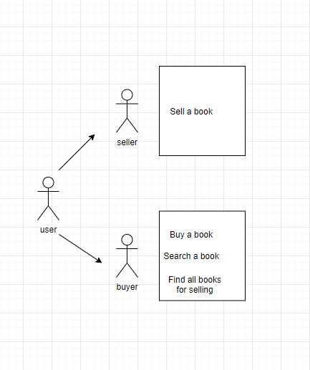

## ERD

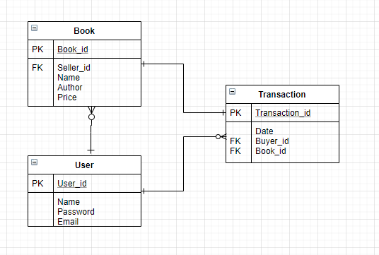  
UML

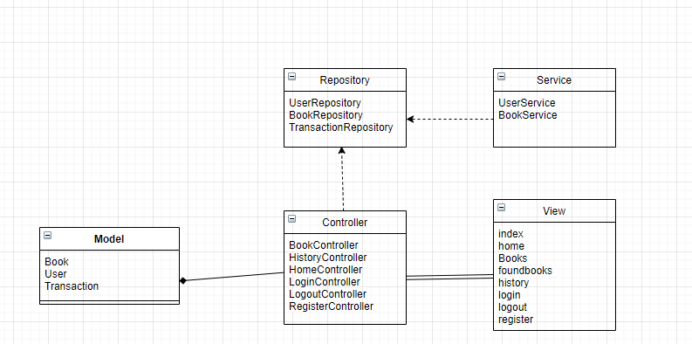

## Wireframes

Index page



Register Page



Login Page

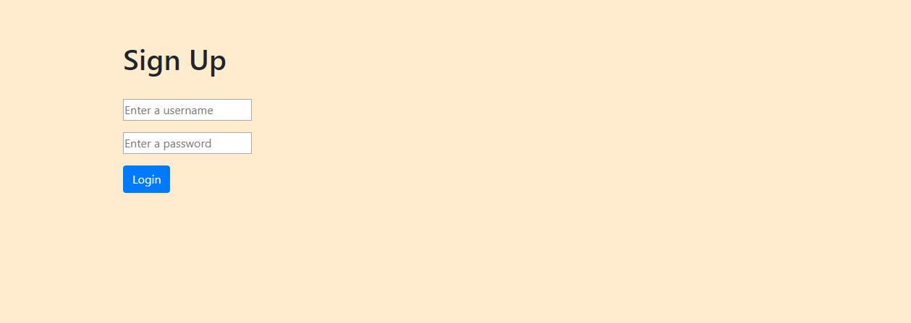

Home page

